***Digital data display system.***

***Circuit diagram:***

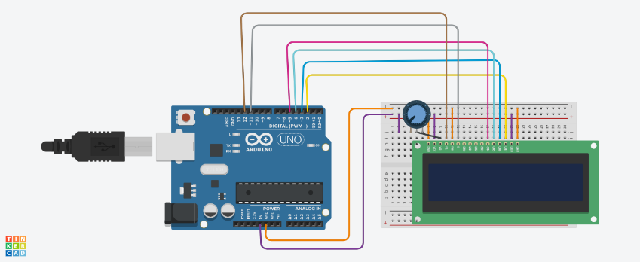

***THEORY:***

***Concept Used:-***

***In this project we have used a concept of led. whatever we want to print on led in different patterns and in different manners we can by the help of this project with the help of different codes working on it.***

***LEARNING AND OBSERVATIOBS:***

***Learnings: -***

* ***How to make use of LCD (digital display system).***
* ***To do coding on Arduino software as well on tinkercad.***
* ***Compiling and uploading codes done on tinkercad.***
* ***Use of tinkercad for making hardware and software.***
* ***Use of potentiometer to have variable length or light and dark shades on LCD.***

***Observations: -***

* ***Working of a software on tinkercad.***
* ***Display of data on LCD in different manners.***
* ***Software and hardware used for making circuit.***

***PROBLEMS AND TROUBLESHOOTING:***

* ***Uploading and compiling of codes.***
* ***Checking connections and underlining defective LCD.***
* ***Checking correct port for software on tinkercad and type of Arduino.***
* ***Correct working of various hardware and software used.***

***Precautions:***

* ***Don’t make loose connections.***
* ***Don’t connect Arduino to the respective pc until the circuit is complete.***
* ***Carefully look on the working of all the devices used while making circuit.***
* ***Carefully look on the working of LCD.***

***Outcomes:***

* ***The circuit is complete and data is displayed on LCD screen.***
* ***Can be used for making many types of patterns or modern watches.***
* ***Can be used as a smart way to display data.***